

**CSIS 3003**

**PRACTICAL PROJECT I**

**Second-Hand Game Disc Purchasing, Selling, Rent, and Exchange Management System (Stage 1)**

**Wong Yik Khen (D170325B)**

**Wong Juin Zheng (D170231B)**

**Ng Weng Kang (D170236B)**

**Lecturer: Mr. So Yong Quay**

**24th April 2018**

**Department of Computer Science**

**Faculty of Engineering and Information Technology**

Table of Contents

Introduction 3

Objective 3

Project Objective 3

Personal Objective 3

Background Research 4

Paktor - An Android application 4

Methodology 5

Iterative model 5

Requirement Specification 7

User Requirements 7

Identification of business process stage 7

Analysis of problem and solution stage 8

Literature Review 10

Research 12

Project Scope 14

Project Schedule 16

Curriculum Vitae 17

References 19

Project Schedule

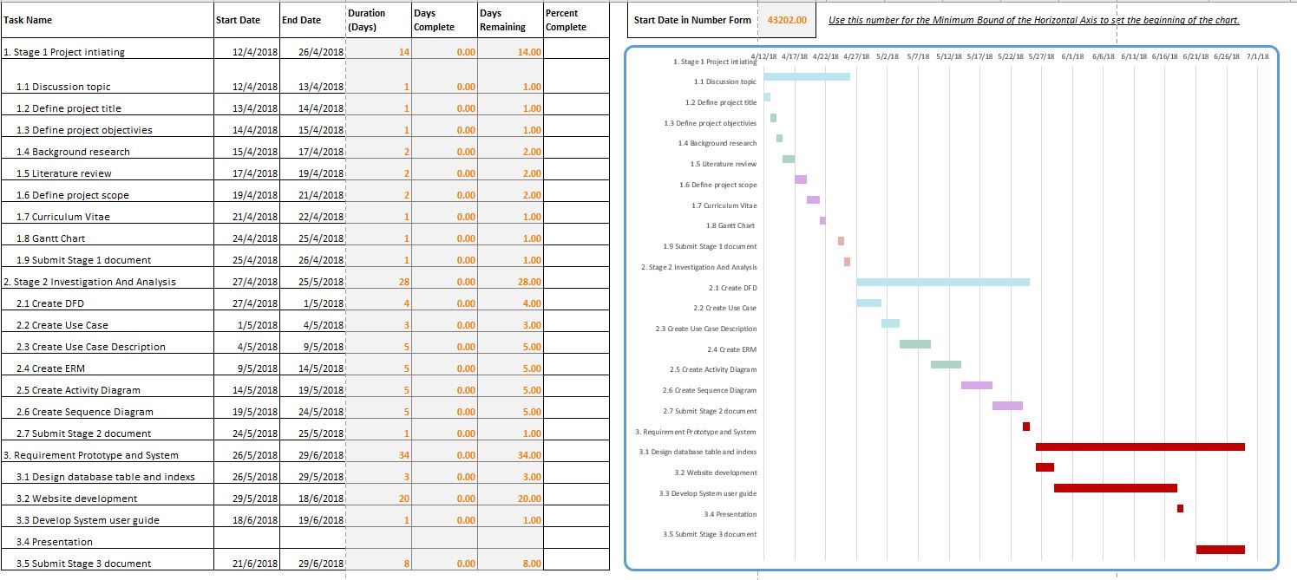

Curriculum Vitae

**WONG JUIN ZHENG**

**CURRENT AND HOME ADDRESS**

47, JALAN KEMULIAAN 37,

TAMAN UNIVERSITI,

81300 SKUDAI,

JOHOR.

|  |  |  |  |
| --- | --- | --- | --- |
|  |  | **PERSONAL PART I CULARS** | |
| **NRIC** | 990719-01-5031 | |  |
| **AGE** | 19 | |  |
| **NATIONALITY** | Malaysian | | |
| **RELIGION** | Buddhism | | |
| **LANGUAGES** | English, Malay and Mandarin | | |
| **SEX** | Male | | |
| **RACE** | Chinese | | |
| **HEALTH** | Excellent | | |
| **MARITAL STATUS** | Single | | |
| **E-MAIL** | [eoss01@outlook.com](mailto:yjk0817@gmail.com) | | |
| **MOBILE NUMBER** | 013-7019419 | |  |

**EDUCATIONS**

**TERTIARY SCHOOL**

|  |  |  |  |
| --- | --- | --- | --- |
| SCHOOL | COURSE | YEAR | RESULT |
| Southern University College | Diploma in Information Technology | April 2017 - Present | **―** |

**SECONDARY SCHOOL (SPM)**

|  |  |  |
| --- | --- | --- |
| SCHOOL | YEAR | RESULT |
| SMK Taman University | January 2011-November 2016 | A(2), A-(3),B(1),C+(1),C(2) |

**AD DITIONAL IN FORM ATION**

**PERSONALITY TRAITS:**

* **Practical and systematic** in completing task.
* **Cooperative and helpful** for team.
* **Able** to take challenges and risks.
* **Ready** and friendly to give full co-operation when work independently and in a team.
* **Committed** to work with a strong sense of urgency.

**Communication Skills:**

* Spoken and write level (Best= 10 and Worst= 1)

|  |  |  |
| --- | --- | --- |
| LANGUAGE | WRITING LEVEL | SPEAKING LEVEL |
| CANTONESE | 1 | 6 |
| ENGLISH | 6 | 6 |
| HOKKIEN | ― | 5 |
| JAPANESE | 5 | 7 |
| MADARIN | 8 | 8 |
| MALAY | 7 | 7 |

**Computer Skills** (Best= 10–Worst= 1)

|  |  |
| --- | --- |
| SOFTWARE/PROGRAMING | LEVEL |
| JAVA PROGRAMING | 5 |
| MICROSOFT OFFICE EXCEL | 8 |
| MICROSOFT OFFICE WORD | 8 |
| MICROSOFT OFFICE POWERPOINT | 8 |
| MICROSOFT OFFICE VISIO | 8 |
| MACROMEDIA FLASH | 6 |
| PHOTOPSHOP | 7 |

**CO-CURICULUM**

**PARTICIPATIONS**

|  |  |  |  |
| --- | --- | --- | --- |
| PROGRAM | POSITION | LEVEL | YEAR |
|  |  |  |  |

References

Android. (2014). *Location and Maps*. Retrieved from Android Developer:

https://developer.android.com/guide/topics/location/index.html

Bade, D., & Puszies, R. (n.d.). *A Webservice-based Context Data Service for the Android* *Platform.* Hamburg, Germany: University of Hamburg, Department of InformaticsDistributed Systems and Information Systems.

Larman, C. (June, 2003). *Iterative and Incremental Development: A Brief History.*

Oracle. (2014). *What is MySQL?* Retrieved from Oracle Corporation:

http://dev.mysql.com/doc/refman/4.1/en/what-is-mysql.html

Paktor. (2014). Retrieved from Paktor: http://www.gopaktor.com/

POCATILU, P. (2010). *Developing Mobile Learning Applications for Android using Web* *Services.* Bucharest, Romania: Economic Informatics Department.

Shu, X., Du, Z., & Chen, R. (n.d.). Research on Mobile Location Service Design Based on Android.

*Web services*. (March, 2007). Retrieved from TechTarget:

http://searchsoa.techtarget.com/definition/Web-services